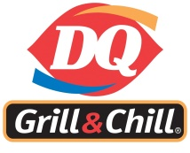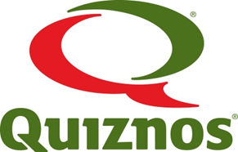

W.S Hawrylak HSCC is excited to host fun lunches on the following dates:

Thursday November 30th, 2017 – DQ
Thursday March 8th, 2018 – Domino’s Pizza and Booster Juice
Friday June 8th, 2018– Quiznos and TCBY

The use of the website www.healthyhunger.ca was a great success last year. As a result, the W.S Hawrylak HSCC will continue to use this website for ordering and processing of all fun lunches. Cash payments will not be accepted for any fun lunch orders.

Please go to https://www.healthyhunger.ca/ where you will be able to create an account, view all upcoming special lunches, place an order for all dates or just one at a time, and pay online. For families that already have an account, once you log in you will need to once again add your child(ren) and choose the correct classroom teacher prior to placing an order. Orders can be placed online until 5 days prior to the dates listed above as this is the cut-off that the website uses to close orders.

REMINDER:
Classroom Supervisors, two parents per class, (11:35am-12:30pm) are needed. If you would like to volunteer your time, please contact your child’s teacher directly.
Thank you from your Hawrylak School Community Council special lunch committee.

